**INNOVATION FOR A BETTER TOMORROW**

* **Anurag N Nair**

What is Innovation ? Innovation means to improve or to replace something, for example, a process, a product, or a service. Innovation is a process by which a domain, a product, or a service is renewed and brought up to date by applying new processes, introducing new techniques, or establishing successful ideas to create new value. So obviously we can consider innovation as a stepping stone for a better tomorrow as the tiltle suggests.



Innovation can be divided into various categories, even we can create our own category of innovation. The term innovation is so vast that any one can pave way for an innovation from the root node. Broadly, innovation landscapes are characterized by well-established categories, such as product, process, organizational, and marketing innovation, explained and theorized in terms of their links with technological innovation. Several authors have also mentioned the term innovation in their own ways and have tried to capture the essentials of innovation and establish common innovation typologies (Garcia & Calantone, 2002; Linton, 2009; Oke, 2007). However, as of yet innovation is an umbrella term involving a myriad of innovation types described as “buzz words” or “container concepts.” Innovation is not only “technological” but also “social,” “cultural,” “institutional,” “inclusive,” “green,” “eco,” “open,” “user-driven,” “lean,” “low-cost,” “grassroots,” “public,” and “transformative” (Edwards-Schachter, 2016).

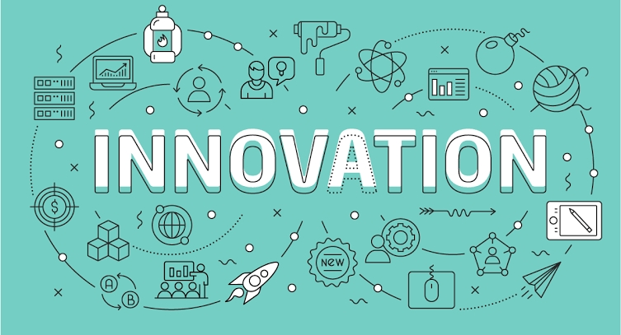

According to latest reports, India has been leading gradually in the idea of innovation. Youngsters are seeking several opportunities to innovate themselves and their societies to create a better living for tomorrow.

We know that throughout the history, innovators and entrepreneurs have made a major impact in the creation for better present-day living conditions by having a impact development, exploration, trade, education, science, and integration. Gradually, innovation would obviously lead to a field of entrepreneurship. During the 20th century, innovation and entrepreneurship have been regarded as key drivers in technological progress and productivity development worldwide. During the recent times Several modern and beneficiary innovations have been entered from the field Information technology, Artificial intelligence, Electronics and Communications etc. These new innovations have also paved way for a major impact and revolutions in those respective fields. These innovations can be considered as a perfect example and inspiration for the upcoming generations to come up with new and meaner innovations. The study of innovation is therefore likely to be an increasingly important topic in, for example, economics, business, entrepreneurship, technology, engineering, medicine, environmental biology, sociology, design, and regional development. Certain innovative concepts includes the Apple Inc. , Tesla, Spacex, Amazon etc.

**“COME LET'S INNOVATE OURSELVES, AND PAVE WAY FOR A BETTER TOMORROW. “**

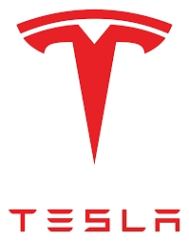

Several quotes by major innovators and entrepreneurs are as follows :

1. “Innovation is taking two things that exist and putting them together in a new way.

Tom Freston (born 1945), Co-founder of MTV

1. “The value of an idea lies in the using of it.“

Thomas Edison (1847 – 1931), Inventor

1. “If I had asked the public what they wanted, they would have said a faster horse.

Henry Ford (1863 – 1947), Founder of Ford Motor Company

Hereby providing the links of various articles to refer to:

1 <https://www.sciencedirect.com/science/article/pii/S2096248718300249>

2. <https://www.tandfonline.com/doi/full/10.3402/aie.v1i1.5601>

3. https://www.google.com/amp/s/hbr.org/amp/2002/08/the-discipline-of-innovation